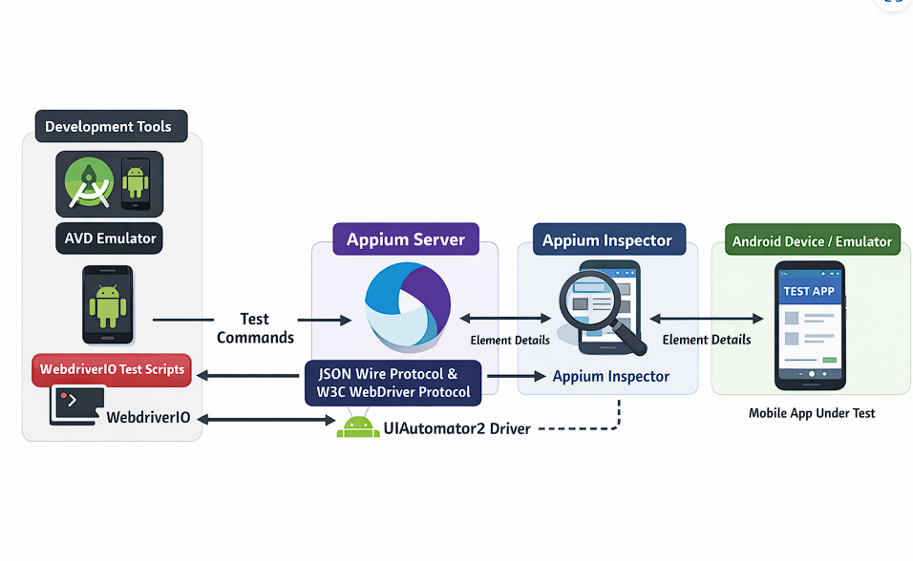

The diagram shows the complete execution flow of an Android mobile automation framework using the Appium ecosystem.
Here is the workflow from left to right.
- Android Studio + AVD Emulator
On the left side, you have the development environment.
- Android Studio is used to:
  - create Android Virtual Devices (AVDs)
  - manage SDKs and platform tools
  - launch emulators
- The AVD Emulator behaves like a real Android phone on your system.
This emulator becomes the target device where the app is installed and tested.
- WebdriverIO Test Scripts
At the bottom-left, you write automation scripts using:
- WebdriverIO
These scripts contain:
- test cases
- locators
- assertions
- actions like click, swipe, input text, etc.
Example:
- Open app
- Enter username
- Click login
- Validate dashboard
WebdriverIO itself does not directly control the phone.
Instead, it sends commands to Appium.
- Appium Server
In the center is:
- Appium
This is the middleware layer.
Role of Appium Server:
- receives commands from WebdriverIO
- converts them into mobile automation instructions
- communicates with the Android device/emulator
Communication happens using:
- JSON Wire Protocol
- W3C WebDriver Protocol
Typical flow:
WebdriverIO Script
↓
HTTP Request
↓
Appium Server
Example command:
findElement
click
sendKeys
- UIAutomator2 Driver
Below Appium Server is:
- UIAutomator2
This is the actual Android automation engine.
Important point:
Appium itself cannot directly automate Android UI.
It delegates the task to UIAutomator2.
UIAutomator2:
- launches automation services on the device
- interacts with Android UI components
- performs taps, typing, scrolling, validations
Flow:
Appium Server
↓
UIAutomator2 Driver
↓
Android Device
- Android Device / Emulator
On the right side is:
- real Android phone OR
- Android emulator
This contains:
- the app under test
- UI elements
- screens and interactions
This is where actions physically happen.
Example:
click(login button)
type(password)
scroll(page)
- Appium Inspector
At the top-right is:
- Appium Inspector
Purpose:
- inspect app elements
- identify locators
- validate UI hierarchy
It connects to the Appium Server and retrieves:
- element IDs
- XPath
- accessibility IDs
- class names
- UI tree structure
This helps students build selectors for automation scripts.
Typical usage:
Open Appium Inspector
↓
Connect to Appium Server
↓
Inspect app screen
↓
Copy locator
↓
Use locator in WebdriverIO script
Complete End-to-End Flow
The entire automation lifecycle works like this:
WebdriverIO Test Script
↓
Appium Server
↓
UIAutomator2 Driver
↓
Android Emulator / Device
↓
App Executes Actions
↓
Results Returned Back
Meanwhile:
Appium Inspector
↓
Reads UI hierarchy through Appium
↓
Helps identify elements
Simple Analogy:
- WebdriverIO = the test writer
- Appium Server = the translator/coordinator
- UIAutomator2 = the Android operator
- Emulator/Phone = the actual device
- Appium Inspector = the UI scanner
- Android Studio = the environment managing Android devices

